Animations, Graphs, Tables and Comments
Animation 1957-2017, effectivity | 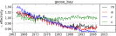 | ftp://crsb.izmiran.ru/LongTimeCRVariation/2018/Animation_effectivity_2017.png
Model_method. Digital_ result. | 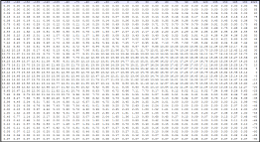 | ftp://crsb.izmiran.ru/LongTimeCRVariation/2018/effectivity/Model_method
Average_Group_method. Digital_ result. |  | ftp://crsb.izmiran.ru/LongTimeCRVariation/2018/effectivity/Average_Group_method
Ratio_Group_method. Digital_ result. |  | ftp://crsb.izmiran.ru/LongTimeCRVariation/2018/effectivity/Ratio_Group_method
Compare (model+group). Graph_ result. |  | ftp://crsb.izmiran.ru/LongTimeCRVariation/2018/effectivity/Compare_Method(model+group)

